Test Cases

1. Empty Validation for airline

Input: “ ”

Expect: Display line “Airline Name cannot be empty”, require user to re-enter

Output:

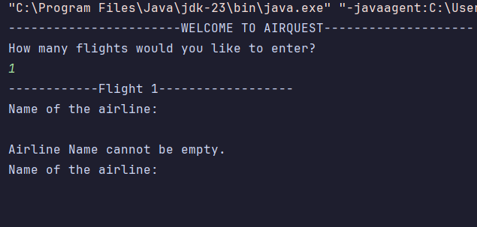

2. Regex Validation

Input: “A_B_@”

Expect: Display line “INVALID: Airline Name must only contain letters and spaces.”, require user to re-enter

Output:

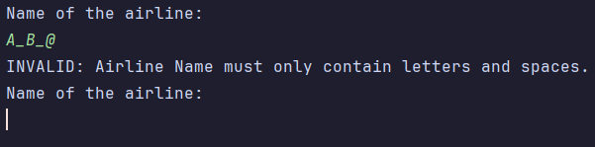

3. Airline name

Input: “Vietjet”

Expect: No Error

Output:



4. Flight Number Validation

Input: “VJ 0625”

Expect: Display line “INVALID: Flight number must only contain letters and numbers.”, require user to re-enter

Output:

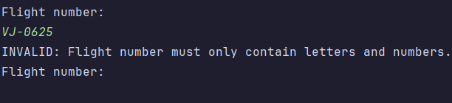

5. Empty Validation for flight number

Input: “ ”

Expect: Display line “Flight number cannot be empty.”, require user to re-enter

Output:

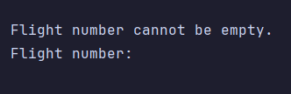

6. String Validation for flight origin

Input: “123”

Expect: Display line “INVALID: Origin must only contain letters and spaces.”

Output:

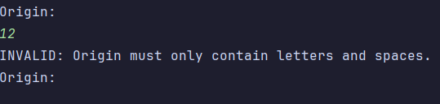

7. Validation for departure time

Input: “11/11/2025 12:00”

Expect:

“INVALID: Date time input does not follow 24-hour-time dd-MM-yyyy HH:mm format.

Please re-enter departure time in 24-hour-time dd-MM-yyyy HH:mm format:”

Output:

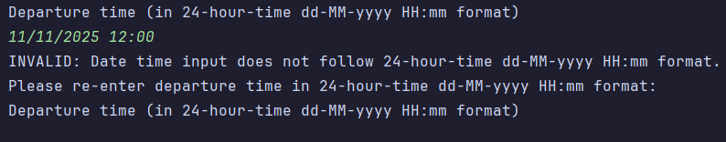

8. Validation Time Format

Input: “11-11-2025 8:00”

Expect:

“INVALID: Date time input does not follow 24-hour-time dd-MM-yyyy HH:mm format.

Please re-enter departure time in 24-hour-time dd-MM-yyyy HH:mm format:”

Output:

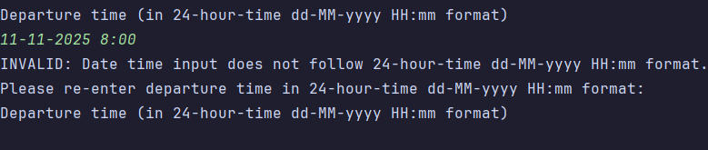

9. Date & Time correct format

Input: “16-06-2025 18:00”

Expect: No error

Output:

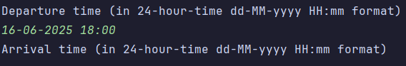

10. Validation Time Logic

Input: Departure Time after Arrival Time

Expect:

“INVALID: Arrival time must be after departure time.

Please re-enter all details for this flight.”

Output:

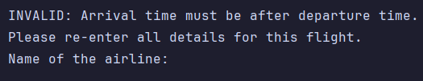

Results

1. Add flight

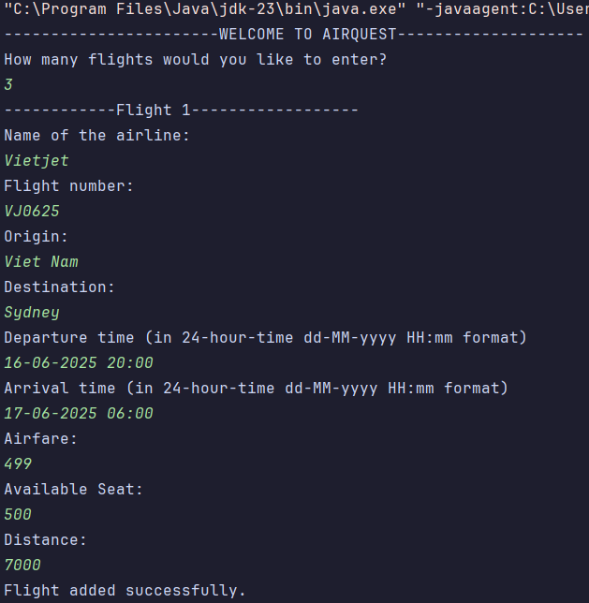

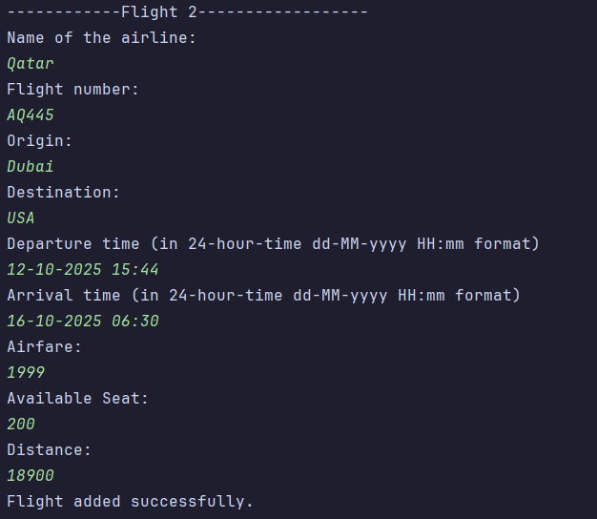

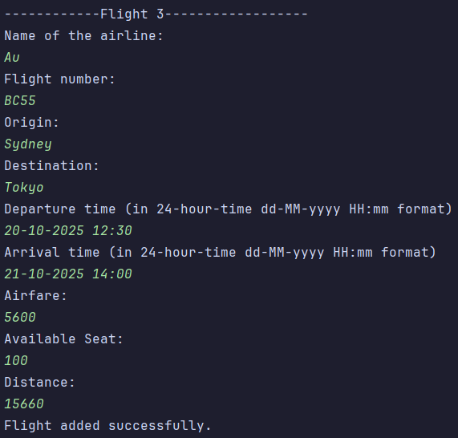



2. Sorting (on console)

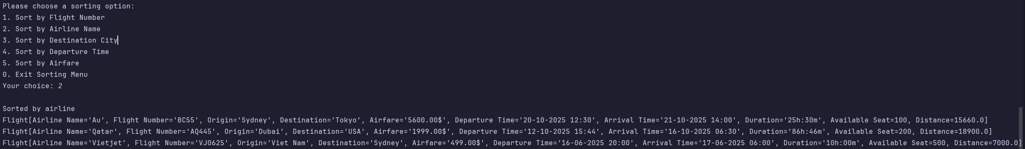

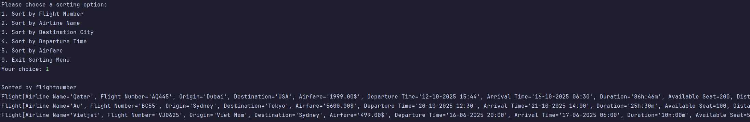

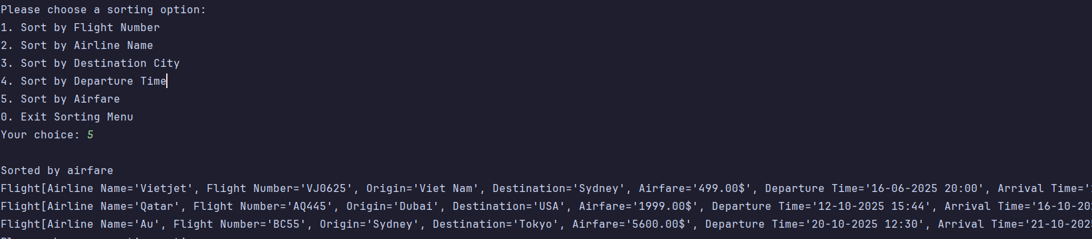

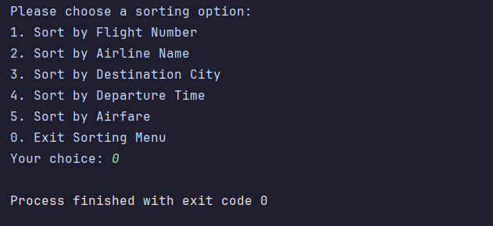

3. Sorting (GUI)

- By Flight Number:

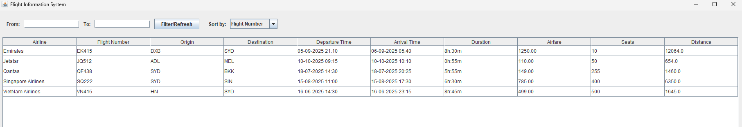

- By Departure Time:

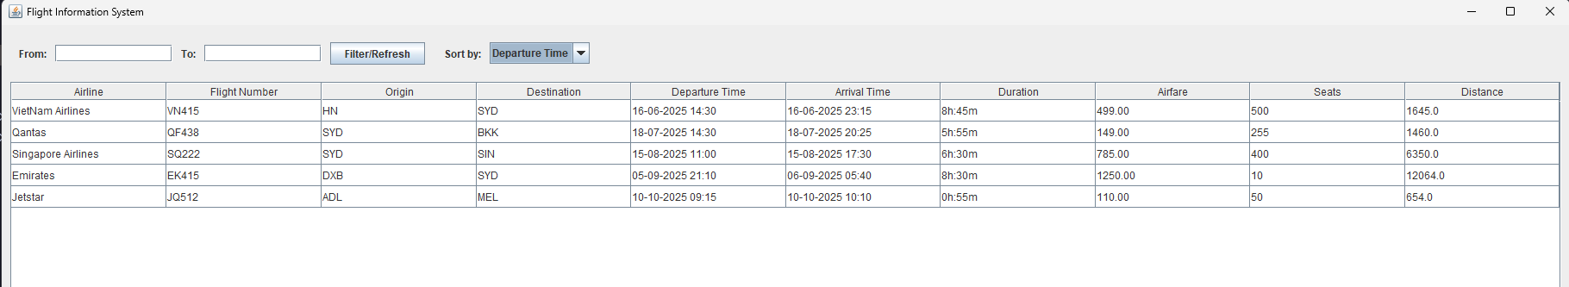

- By Airfare:

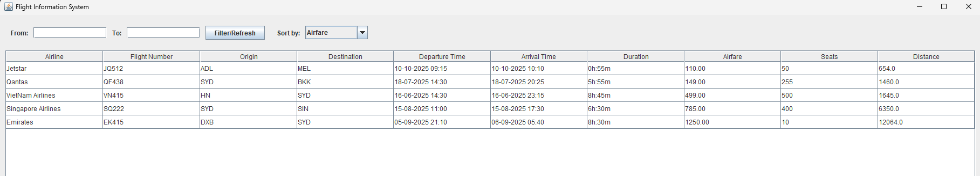

- Filter:

